Beckhoff TwinCAT Program Block XML Structure
Top-Level Structure
Contains the project, block and software related information
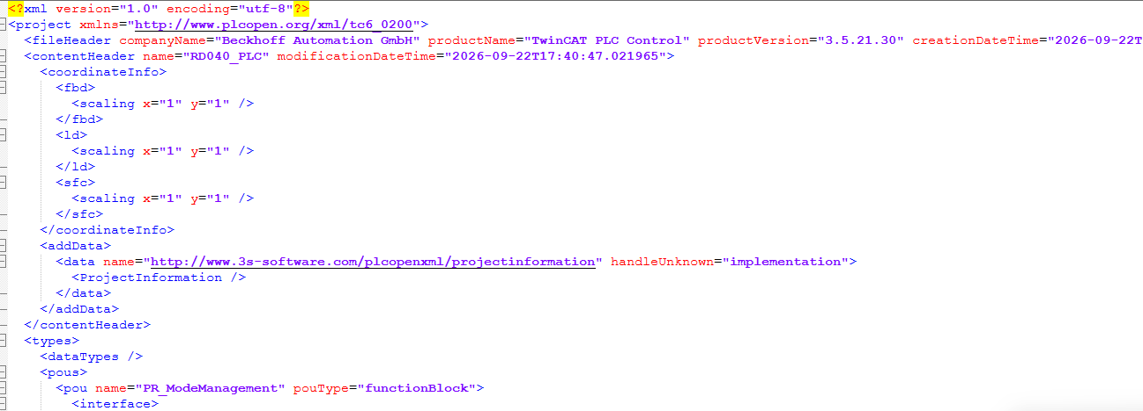
Interface Variables
The <interface> section contains variable declarations grouped into sections. Each variable has a <type> element and an optional <documentation> element containing XHTML description text. Tag is added as per the its type like <inputVars>, <outputVars>
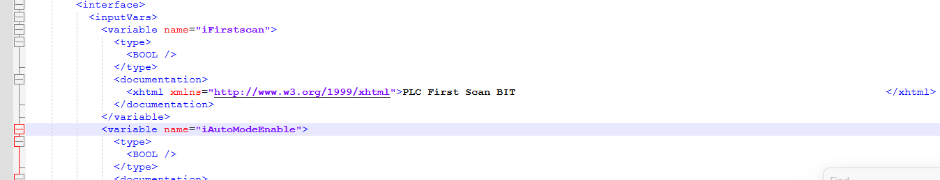
Ladder Diagram Body (LD)
The <body> section contains the logic in Ladder Diagram (LD) format. Key XML elements used are:
- <leftPowerRail> / <rightPowerRail> - left and right power rails of the ladder rung
- <contact> - normally open (negated=false) or normally closed (negated=true) contact
- <coil> - output coil driven by the rung logic
- <block> - function block call (e.g., R_TRIG, TON, MOVE, LE, GT)
- <inVariable> - literal or variable value fed as a block input
- <vendorElement> - TwinCAT-specific element (e.g., network title, parallel branch)
- <comment> — documentation comment attached to a network
Every element carries a localId for cross-referencing. Connections use <connectionPointIn><connection refLocalId="N" /></connectionPointIn> to wire elements together.

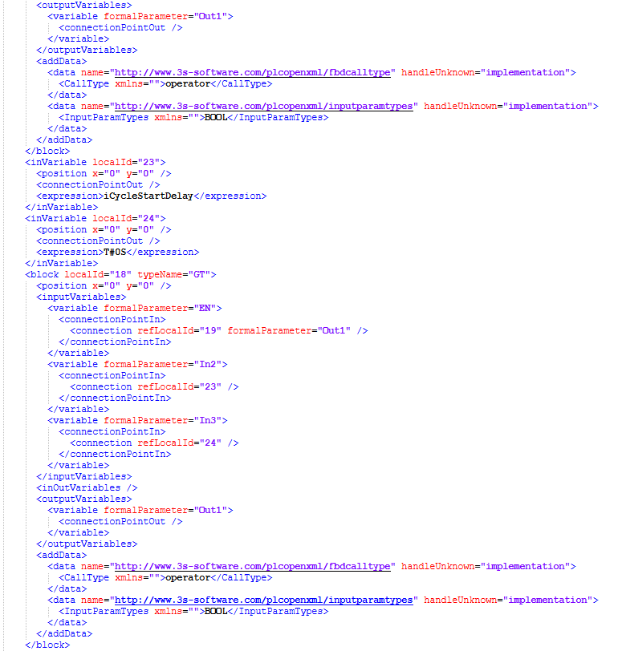
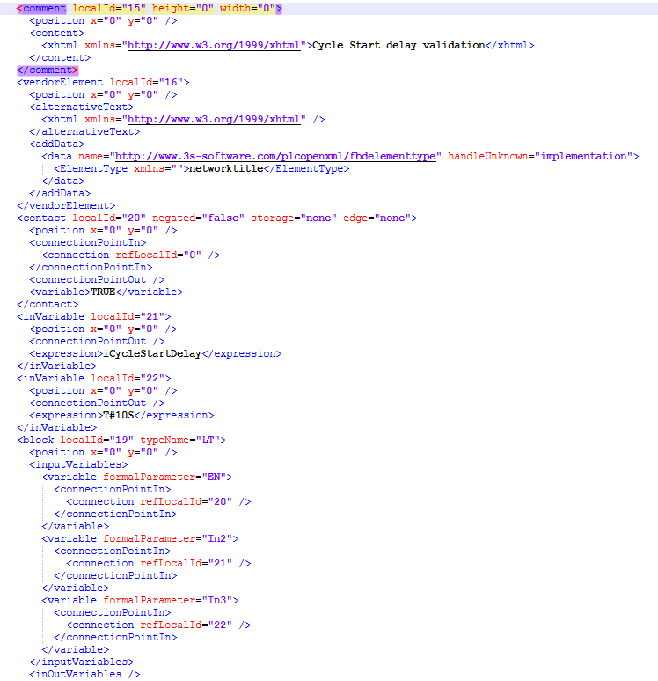
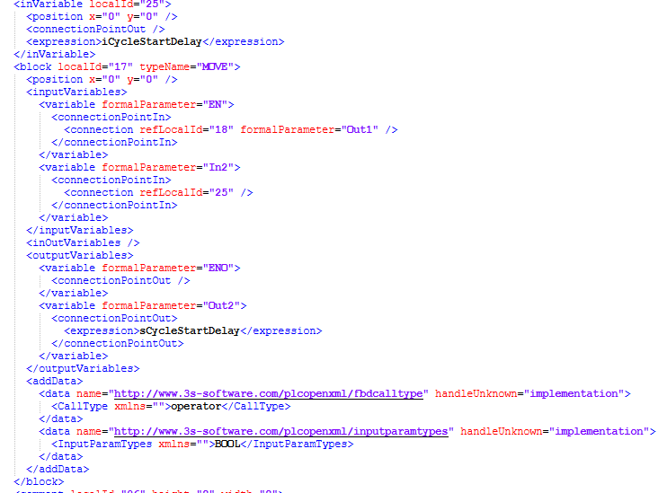

Siemens Program Block XML to Beckhoff Program block XML Conversion

The overall conversion process is:
Siemens Block XML
→ Read XML using C#
→ Extract PLC block/interface information
→ Extract LAD networks
→ Convert Siemens instructions into IEC/PLCopen representations
→ Generate TwinCAT PLCopen XML
→ Validate generated XML
→ Import into TwinCAT
Generate And Save TwinCAT xml
TwinCAT Block XML formator logic

Instruction Mapping for Contact, Coil, AND / OR, MOVE, TON, Comparisons, NOT / etc.

Siemens Data Model for extract FB / Variables, Networks / Parts,Wires / Constants

C# XML Parser XmlDocument / LINQ

Input Siemens TIA Portal Block XML

